
Fountain Gate Primary School

STUDENT ENGAGEMENT & WELLBEING POLICY

Produced in Consultation with the school community
To be read in conjunction with
Effective Schools are Engaging Schools-
Student Engagement Policy Guidelines
December 2020
Principal- Jenny Duggan
School Council President- Hermina Melkic

Table of Contents

- School Profile Statement page 1
- Whole school Prevention Statement page 2
- Rights and responsibilities page 5
- Shared Expectations page 11
- School Actions and Consequences page 16
- Students in need of extra support page 21
Fountain Gate Primary School
Student Engagement Policy

- School Profile Statement
Fountain Gate Primary School is situated in a quiet residential area of Narre Warren, within close proximity to neighbouring schools Dandenong Valley School and Fountain Gate Secondary College.
The school serves a diverse community, with 63% of its population speaking a language other than English at home and 35 different nationalities represented. The multicultural nature of our school is a great strength, as children prepare for a global future, where differences command work, resolution, openness and understanding.

Enrolments currently sit at 470. There is a near gender balance amongst the student population. The school focuses keenly on meeting the needs of its culturally diverse community, which also has a low socio-economic status. Our Student Family Occupation is 0.71 and 60% of families receive EMA support. There are 24 children who receive funding under the Program for Students with Disabilities.
Building lifelong learning and positive relationships through a learning community is a school priority and the shared and agreed values of respect, trust and care are visibly at the core of our mission to know, inspire and challenge every student everyday.
The school’s staffing profile consists of 44 full time and 29 part-time personnel. These numbers include the principal, 2 assistant principals, 1 Leading teacher, 31 Class 2 teachers, 13 Class 1 teachers, 4 ES1-3 staff, 2 ES1-2 staff and 7 ES1-1 staff.
The Specialist and Intervention programs include Art, Physical Education, Music (0.6), Science (0.6), Literacy Intervention 3.0, Phonemic Awareness 0.8, and Maths In Action 2.0.
The school currently has 23 classes from Prep to Year 6. Fountain Gate Primary School has a strong commitment to meeting the needs of 21st century learners, with high level learning technologies throughout the school. “Restorative Justice” is an approach to student development and management that emphasizes the health of relationships by helping participants develop empathy and associated interpersonal skills. For the majority of students, this has been a very effective model. Improvement in Peer and School connectedness, and student safety has resulted.

- Whole School Prevention Statement
Fountain Gate Primary School aims to improve the social competence of students, fostering empathy, negotiation and problem solving through a restorative justice model.
“Restorative Justice” is an approach to student management and development that aims to teach children how to build and maintain positive relationships with others. This approach has been successful in fostering skills and attitudes such as empathy for another person, negotiating outcomes that benefit all parties, and understanding that our actions have the capacity to impact on others. Our continued improvement in results for “Student Safety” in the student opinion survey suggest that this approach is helping our children feel safe and connected at school.
Student engagement and wellbeing is of paramount importance at Fountain Gate Primary School. Feelings of safety, belonging and happiness enable lifelong learning to be developed. The school has many programs in operation that, together with the interpersonal skills of staff, create an environment where high levels of connection between individuals are in evidence.
All wellbeing initiatives occur within the context of the school’s values; Respect, Trust and Care.
The values of respect, trust and care are visible around the school, in classrooms and within school documents. A behavioural understanding of these values is strong throughout the student, staff and parent community and developed through a common language within conversations. Student input into the learning environment occurs annually through the ‘It’s Up To Us!’ program at the start of each year and a range of prevention programs follow throughout the year. The language of wellbeing is embedded in the learning culture, and acknowledged and supported through student awards and specific feedback. The school invests significant time in supporting the needs of individual students through tailored management plans which contain specific strategies relevant to the individual students and it focuses its resources in response to the needs of specific students.
Staff capabilities and empowerment for whole school consistency in student management has been achieved through relevant professional learning opportunities including Restorative Justice and the Zones of Regulation practices, as well as the Rights, Resilience and Respectful Relationships Curriculum.
Fountain Gate Primary School responds to the needs of individual students by:
- Referring them for the Program for Students with Disabilities
- Referring them to the school chaplain
- Referring them to paediatricians, psychologists, audiologists etc,
- Linking them with tutors
- Involving them in targeted social skills lunchtime activities, e.g. garden groups, sports, robotics, social skills and more
- Involving the child/family with outside agencies such as Child First, DHHS, cultural support, health & disability and/or youth services to name but a few.

The following Prevention Programs are put in place to support our students in attending school, participating in class and enjoying learning:

- Rights, Resilience & Respectful Relationships curriculum taught weekly across the whole school
- Restorative Justice approach
- Growth Mindset approach
- Zones of Regulation used as common language across the whole school
- Various Awards- including Student of the Week, Citizenship, Playground
- Buddy program- Fostering positive relationships between older and younger students.
- Peer Mediation- Year 5 and 6 school students.
- Circle Time activities- Resource tubs allocated to each Level
- Mindful Meditation, focussing on self-awareness
- Transition- The school has focused on two main transitions, that of preschool children to primary school and primary to secondary transition.
- Learning Improvement Plans
- School chaplain- Individual case work/ group work/garden group
- Grade 3-6 camping program
- School captains- drawn from years 5 and 6
- Language Support program- Focuses closely on the development of phonemic awareness, which are key skills in acquiring literacy
- Levelled Literacy intervention levels 1-6
- Maths Intervention program levels P-2
- Wellbeing sessions taken by the Student Wellbeing Leader in every class: focus on Zone of Regulation
- School assemblies- school ethos will be supported, informed and promoted
- Health and Wellbeing coordinator- with a whole school focus
- Home/school contact and communication- this will be initiated when required to individual parents/carers and through the newsletter for the whole community
- Junior School Council- the membership will be drawn from grades 3 to 6.
- Supervision- 4 teachers on yard duty; ticket system for entry to school and sick bay
- Guest speakers and PD- to develop parent and teacher skills
- Newsletters- community communication and involvement
- Regular Student Support Group meetings for integration students
- School based psychologist

How we support positive behaviour and relationships
At Fountain Gate Primary School we have a consistent and positive approach to behaviour which fosters a school climate where personal responsibility and self-discipline are developed. We are proactive in helping students develop skills and knowledge at all levels of achievement and maturity. We have high standards of behaviour, and strive to put in place necessary measures to assist children in achieving these standards. Wherever possible, programs and approaches that focus on prevention are implemented. Intervention strives to take into account the most effective way to assist individual students.

We are committed to developing:

Self-Acceptance: Accepting ourselves, even when we make a mistake, or have a difficult time. Being aware of and appreciating our strengths and weaknesses.
Risk Taking: Trying new activities, even when we might not be able to do them at first.
Being Independent: Being confident about our own point of view, and not being overly concerned about what others think of them.
Optimism: Making positive predictions about the future.
Giving Effort: The harder we try, the more successful we will be. Giving everything our “best shot”.
Working Tough: Thinking that in order to be successful, we sometimes have to do things that are not easy or fun.
Goal Setting: Setting short term and long term goals. Achieving goals leads to feelings of success.
Time Management: Planning and organising our time so we get important things done.
Tolerance of others: Accepting people with their differences. Not making overall judgements about others.
Thinking First: Thinking before acting. Thinking about consequences.
Playing by the rules: Being able to tolerate limits on behaviour. Knowing that everyone’s rights are important.

When behaviours and events occur that could compromise the positive approach that we have built, we will use the restorative approach
FOUNDATION:

Restorative Practice Questions
- What happened?
- What zone are you in? (If applicable: What zone were you in when ** happened?)
- Who was affected by what you did (and in what way)?
- What have you thought about since?
- What do you think you need to do to make things right?
- How do you get out of that zone now/next time?

These questions are modified by staff to suit different students and situations. However, the intent and order largely remain the same.

JUNIOR:

Restorative Practice Questions
- What happened?
- What were you feeling at the time?
- What have you thought about since?
- Who was affected by what you did (and in what way)?
- What do you think you can do to help yourself/other person move back into the green zone now?
- What can you do next time a similar incident to this occurs?

These questions are modified by staff to suit different students and situations. However, the intent and order largely remain the same.

MIDDLE/SENIOR:

Restorative Practice Questions

Let the student/s know that it is okay to sometimes be in the blue/yellow/red zone - it’s what we do with our feelings while in those zones that matters.

- In one word, (all involved) tell me how are you feeling? (NB: Zone cards are in the YD bags, these could be used for students to point to if they’re too upset to speak)
- What happened (one person at a time)?
- What zone were you in when this happened?
OR what zone are you in now?
- How do you think the other person would be feeling (use your zones)?
- What do you think you need to do to make things better?
(NB: Students should be able to articulate more then ‘say sorry’ - inquire about their behaviour/reaction for similar situations in the future)
- If you do not follow what you have said, what do you think should happen?
- How can you get back to the green zone now?

This approach focuses on respecting and supporting all involved and rather than seek punishment, it will endeavour to correct the wrong that has been done and give those involved the opportunity to move forward in a positive way. Restorative practices will be embedded in classroom teaching and learning. It will be conducted in an informal way for minor incidents such as disagreements and for more serious incidents such as bullying or fighting , a more formal restorative conference will be undertaken, with documentation taking place.
Where a restorative conference has taken place and the behaviour continues, a support group will be formed and strategies to address the behaviour will be put in place. This may include intervention from external community agencies.
At all times, a Restorative approach will be positive, respectful and mindful of the feelings of all involved. We encourage students to have ownership over their feelings and action and the way they interact with others at school.

- Rights and Responsibilities
All members of our school community have the right to feel safe and welcomed in our school.
Our students, their parents/carers and our staff will treat each other with dignity and respect at all times.
At Fountain Gate primary school, we believe that the most effective way of monitoring behaviour is to have a genuine whole school approach where staff, students and parents work together to create a culture where the community is able to identify bullying behaviour and take action to stop it.
A common purpose holds people together and helps everyone to see how their contributions are part of a whole.
Our school’s values and rights and responsibilities have come about through a whole school and community involvement.

Fountain Gate Primary School is committed to creating a safe and inclusive environment for all its students, including LGBTIQ students.
It promotes the cultural safety of Aboriginal children; children from culturally and/or linguistically diverse backgrounds and the safety of children with a disability.
The school has a process in place to ensure that children know who to talk to if they feel unsafe or have a concern and as part of our Student Engagement and Wellbeing Policy, students and teachers are informed and are aware of their rights and responsibilities.
Process:
Child → Staff → Wellbeing Coordinator → DHHS or other relevant organisations such as the police
In the event of the Wellbeing coordinator being unavailable, the Principal, the Assistant Principal, or the Leading teacher will manage any allegations of disclosure.
(For further information, refer to the Fountain Gate Code of Conduct B)
We implement the process by:
Modelling a commitment to child safety at all times
Ensuring an inclusive environment which is free from any form of discrimination and enables open communication
Regularly communicating the process to staff and the wider community
Responding appropriately to any reports or concerns by taking action that is timely, respectful and coordinated.
Documenting all allegations or concerns and retaining records in a secure area, ensuring their confidentiality.
Providing educational programs that empower students and ensures that they understand their rights.
Ensuring that support is given to students impacted by abuse, including a Student Support Plan in consultation with wellbeing professionals.

When staff members form a reasonable belief that a child has been harmed, or at risk of harm, they are ethically bound to take action to protect the safety and wellbeing of that child.
3.1 The Equal Opportunity Act 1995 makes it unlawful to discriminate against a person on the basis of the following attributes:
- age
- breastfeeding
- gender identity
- impairment
- industrial activity
- lawful sexual activity
- marital status
- parental status or status as carer
- physical features
- political belief or activity
- pregnancy
- race
- religious belief or activity
- sex
- sexual orientation
- personal association (with a person who is identified by reference to any of the above attributes).
3.2 The Charter of Human Rights and Responsibilities Act 2006 is an Act of Parliament that clearly sets out our rights and freedoms, and the responsibilities that go with them, in one document. The Charter focuses on civil and political rights, and includes well known democratic rights such as the right to vote and freedom of expression.
Although the Charter sets out a list of 20 rights, they all reflect four basic principles. These are: Freedom, Respect, Equality and Dignity.
All DEECD employees must act compatibly with the Charter and give proper consideration to human rights when making decisions.
3.3 The Federal Disability Discrimination Act 1992 (D.D.A.) provides protection for everyone in Australia against discrimination based on disability. It encourages everyone to be involved in implementing the Act and to share in the overall benefits to the community and the economy that flow from participation by the widest range of people.
3.4 The Disability Standards for Education were formulated under the Disability Discrimination Act 1992 to provide a framework to ensure that students with disability are able to access and participate in education on the same basis as other students. An Education provider must treat a prospective student with a disability on the same basis as a prospective student without a disability. Before the education provider makes an adjustment for the student, the education provider must consult the student about whether the adjustment is reasonable and the extent to which the adjustment would achieve their aim.
3.5 The Education and Training Reform Bill passed the Legislative Council of the Victorian Parliament on Thursday 4 May, 2006 and received Royal Assent through the Governor in Council on Tuesday 16 May, 2006 after a two year process of development and consultation. The Education and Training Reform Act 2006 builds on the strengths of Victoria’s previous education legislation but also reflects the reality of contemporary education. Its main purpose is to set out a legislative framework that will underpin quality education delivery in Victoria, both now and well into the future.
The Act came into effect when it was proclaimed on Sunday 1st July 2007 by the Governor in Council.

3.6 The Childrens’ Youth and Families Act 2005.The main purposes of this Act are:
(a) to provide for community services to support children and families; and
(b) to provide for the protection of children; and
(c) to make provision in relation to children who have been charged with, or who have been found guilty of, offences; and
(d) to continue The Children's Court of Victoria as a specialist court dealing with matters
relating to children.

STUDENT RIGHTS

You have a right to be respected, care about yourself and have others care about you.
You must treat other people with respect and in turn they will treat you kindly, avoiding harsh words and actions. To respect yourself, you must act fairly, kindly and allow yourself to develop through participation in a range of fulfilling experiences.
You have a right to work and play games without being disturbed.
To develop academically, physically, emotionally and socially you should learn and play without interruption from those around you.
You have a right to expect the use of good manners at all times.
Children and adults should converse with others courteously for positive interaction to occur within our school environment. These skills should prepare children for favourable dealings with people in the wider community.
You have a right to be physically and emotionally safe at school.
School equipment, playing areas and classrooms should be maintained to ensure that all students are able to feel safe in their environment. Areas or equipment deemed unsafe should be reported to the Principal immediately.
You have a right to learn about the world and yourself.
Students must be provided with varied and interesting resources and learning opportunities in order to broaden their knowledge about themselves and the world around them.
You have the right to have fun and enjoy school.
A trusting, friendly, happy and challenging environment provides children with the best learning opportunities and experiences.

You have the right to have a say in what is happening in our school.
Opportunities for student involvement in school decisions allow children to feel valued as a member of the school community. Classroom discussions and Junior School Council involvement provide children with a mechanism to voice opinions and concerns.
You have the right to have good school equipment.
For children to reach their ‘personal best’ at this school and enhance learning opportunities, they must be provided with a range of useful, challenging and safe equipment.

STUDENT RESPONSIBILITIES (These are the main expectations of our school).

You have a responsibility to respect and take care of yourself and others.
Students and adults should feel respected in our school and we should look after others, as all members of the school community need to feel safe, valued and cared for.
You are responsible for acting in a safe manner.
Through acting safely at all times, we should keep ourselves fit and healthy and allow others to keep well and feel secure in the school environment.
You have a responsibility to take care of your property and that of others.
Everybody wants to gain enjoyment through playing with and using great equipment. If things are broken, enjoyment is lost and people can feel sad and hurt. By being responsible for our own things, we can learn to appreciate and care for possessions of others.
You have a responsibility to resolve problems calmly, sensibly and fairly.
To deal with conflict appropriately, a child must listen to and understand the point of view of the other person. Each party must show respect for differences and look for a way to resolve the problem so everyone can feel satisfied with the outcome.
You have a responsibility to wear approved school uniform.
By wearing a school uniform, we are identifying ourselves as part of a group. This group works together to achieve joint goals. Individuals also set about achieving their own goals. We should feel proud of our involvement in the school community where we learn and grow and honor it through proudly wearing our school uniform.

STAFF COMMITMENT
All staff, both teaching and non-teaching will demonstrate commitment to Fountain Gate Primary School by:
- effectively implementing and achieving the school goals and priorities.
- treating members of the school community with understanding and respect.
- communicating with and offering support to one another.
- demonstrating a positive role model by way of behaving and dressing in an appropriate manner.
- demonstrating the ability to manage and adapt to change.
- Contributing to and supporting school community activities.

TEACHER RIGHTS & RESPONSIBILITIES

Teachers have a right to receive respect, courtesy and support from all members of the school community.
Teachers can teach students effectively when they feel valued and able to teach using a wide range of strategies. Working without interruptions and being provided with opportunities to develop personally and professionally through professional development opportunities allows teachers to teach to their optimal ability. Receiving support in their environment enables all members of the school community to experience the full benefits of a teacher’s ability.
Teachers have a responsibility to implement the student code of conduct fairly, reasonable and consistently.
Students need to feel that they have received fair and consistent treatment in the school environment. Teachers must ensure that students are aware of their rights and responsibilities and act appropriately to deal with issues that are in breach of student rights and responsibilities. The safety of students is to be maintained at all times.

TEACHING

Teachers at the school are part of a team, responsible for providing high quality programs to ensure success for students within a safe, happy and orderly environment.
In addition to specific role statement teachers will:
- recognise that all students have the capacity to learn and be taught.
- treat students justly and equitably.
- have an understanding of how students develop and learn.
- recognise and cater for individual students’ capabilities and learning styles.
- develop and evaluate effective teaching and learning strategies.
- encourage and empower students to take increasing responsibility for their own learning.
- promote high but achievable expectations for students.
- foster student confidence and self-esteem.
- ensure that the school environment is safe, caring and purposeful.
- monitor and assess students by using a variety of techniques.
- report to students and parents in a meaningful, clear and accurate manner.
- familiarise students with the structure and functioning of society.
- convey the culture and values of society.
- be effective communicators.
- encourage students to analyse the merits of different positions in order to form their own judgements.

WITH THE SCHOOL COMMUNITY

Teachers at Fountain Gate Primary School have a responsibility to be:
- Open, honest and sensitive in relating to parents and guardians.
- Receptive in seeking active co-operation and participation of parents and guardians in student welfare and educational development.
- Respectful of parents’ and guardians’ roles and right to privacy.
- Impartial in responding to student learning needs.

RELATIONSHIP WITH COLLEAGUES

Teachers at Fountain Gate Primary School have a responsibility to:
- Share good practices and materials to maintain and improve the standard of education in the school in accord with its agreed priorities and goals.
- Develop positive, effective and co-operative relationships with other staff.
- Maintain appropriate confidentiality.
- Expect trust, respect and support from their colleagues.
- Be receptive to other’s points of view.

RELATIONSHIP WITH ONESELF

Teachers at Fountain Gate Primary School have a responsibility to:
- Be thoroughly acquainted with their responsibilities.
- Maintain current knowledge of appropriate educational, social and environmental issues which affect their work.
- Accept the need for accountability for the exercise of their own professional practice.

Community
Fountain Gate Primary School regards parents/carers as co-educators and warmly welcomes and encourages their involvement in all aspects of the school community. Each person’s contribution is valued and assists in the smooth running of all school practices.

RIGHTS & RESPONSIBILITIES

Parents have a responsibility to support the school in its effort to maintain the co-operation of students.
It is important that children learn to respect themselves and others. Parents are encouraged to show interest in their child’s learning and provide a caring and supportive environment at home by familiarising themselves with school issues, events and policies they can show their child that learning occurs best when parents, children and teachers are working together.

Parents have a right to be informed of a child’s behaviour.
Parents need to feel that they can approach teachers to discuss their child’s progress at any time during the year, by appointment. By being aware of their child’s behaviour, co-operation can exist between staff and parents to enable the child to modify behaviour and make the most of learning opportunities.
Parents have the right to receive respect, courtesy and support from all members of the school community.
Parents can expect to receive information about their child’s learning and advice to implement strategies for further development of learning. Confidentiality about family issues is expected and empathy and understanding should be provided.
The school values:
- Support for its educational programs and maintenance of school buildings and grounds from parents and the community.
- Representation on School Council and sub-committees, e.g. Parents and Friends Association.
- Provision of volunteer helpers for canteen, excursions, school events and uniform sales.

The school community is responsible for:
- Maintaining mutual respect and confidentiality between staff, students and parents.
- Providing the opportunity for the purchase of educational materials, equipment and uniforms necessary for effective day to day activities.
- Relaying important information between staff and parents.
- Ensuring appropriate duty of care and supervision in and away from the school environment, i.e. school excursions and camps.
- Supporting the school in its efforts to maintain the co-operation of students.

Whenever access is obtained to community resources, i.e. shared sporting facilities and local resources, Fountain Gate Primary School will ensure that:
- The demands placed on the resources are not excessive.
- The rights of community members will be respected and the resources cared for.

The school community has the opportunity to be kept fully informed of the school’s activities and achievements through:
- Reading the weekly newsletter.
- Attending the Annual General Meetings of School Council.
- Accessing school council written reports.
- Attending parent/teacher interviews and reading school reports.
- Attending open and orientation days.

- Shared Expectations
Fountain Gate primary school has developed shared expectations to convey the core purpose of the school, including what we would like to see in the future and the shared values we have agreed upon about what is desirable and worthy and could guide our behaviour.
Our school community is diverse in terms of backgrounds and experiences and our shared expectations are intended to support all within it.

Our Mission
To know, inspire and challenge every student everyday.

Our Vision
Fountain Gate Primary School is a community of active, focused learners who share their curiosity, voice and expertise with others and themselves.
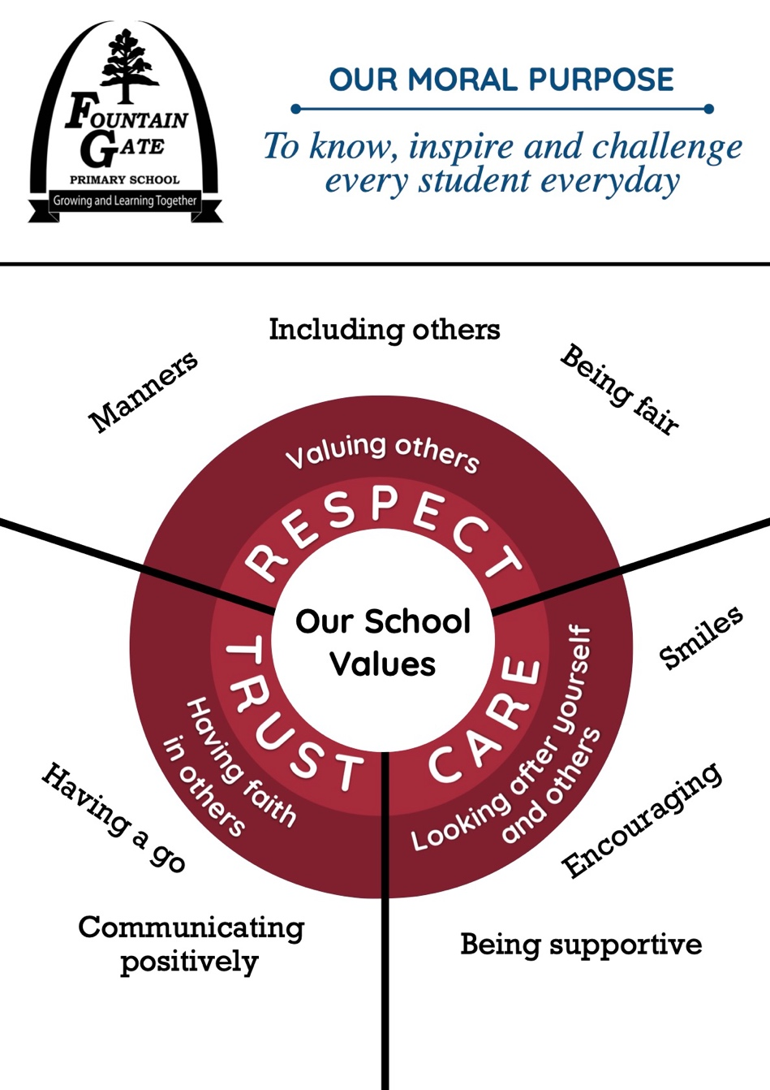

Our Values

Expectations- Students
The school rules are:
- Play and work safely without fighting and putdowns
- Show courtesy, consideration and good manners to others
- Respect and take care of their property, that of others and their school
- Follow all staff instructions
- Try their best to learn, and let others learn
Attendance
To ensure that maximum benefit is gained from school experiences, all students are expected to attend school every day of the school year. Being on time is encouraged unless valid grounds exist. If students are absent, parents are required to provide an explanation the Compass app.

Behaviour
All students are expected to:
- Have a growth mindset and value self-acceptance. Students are encouraged to accept themselves, even when they make a mistake, or have a difficult time
- Take responsibility for their own learning and support others in theirs. Use zones
- Plan and organise their time so that they can get things done
- Be respectful of the rights and/or differences of other individuals at the school. Demonstrate behaviour and attitudes that support wellbeing.
- Understand that bullying, including cyber-bullying, inappropriate language, vandalism and violence is not acceptable
- Be aware of the school’s Anti-Bullying policy and behaviour flowchart (titled: what happens when my behaviour affects others?)

Expectations- Staff
Engagement
Staff at fountain Gate Primary School will:

- Provide students with a nurturing, stimulating environment that promotes meaningful, challenging and developmental learning for life.
- Deliver purposeful teaching and have high expectations of all learners.
- Continue to improve learning opportunities and lift achievement.
- Embed a cycle of planning, teaching, learning and assessing to better meet differentiated learning needs.
- Continue to develop student responsibility for their own learning
- Build staff capacity to transfer professional learning into classroom practice through the school’s performance and development culture.
- Increase the accuracy and consistency of assessment.
- Strengthen the planning, teaching, learning and assessing cycle which underpins continued improvement and gives students self- confidence.
- Collaborate with student services and community linkages which are inclusive and responsive to student needs.
- Collaborate with students and parents/carers to ensure their continued participation in the decision making process.

Attendance
The staff at Fountain Gate Primary School will
- Promote and support good attendance
- Regularly inform the school community of attendance expectations
- Have appropriate protocols and procedures in place to support student attendance
The Attendance Officer monitors attendance records daily and based on the information, corresponds with families by making relevant phone calls, emailing and/or sending letters requesting further information and clarification. Parents are asked to update absences through compass on the day of an absence.
Behaviour
Staff at Fountain Gate Primary School always model positive behaviour with each other and the students. This means that they treat students as responsible people and address them with a tone of respect and care, even when their behaviour has been unacceptable.
Teachers will:
- Ensure that a consistent student management procedure exists in the school.
- Support the development of positive relationships between students and others in the school community.
- Develop a sense of belonging for students so that positive behaviour is more likely to be demonstrated and sustained.
- Recognise student’s achievements.
- Foster the school values of respect, trust and care in the students to lead to personal growth.
- Foster positive decision making.
- Teach appropriate skills and understandings to improve behaviour.
- Demonstrate high expectations and have supports available that promote positive behaviour.
- Use non confrontational intervention to achieve a desired change of behaviour.

Expectations- Parents/Carers
If we are to reach our goal of producing successful students, we must partner with those ultimately responsible for those students- their parents.
Fountain Gate primary School encourages parents/carers to:
- Establish and maintain a good working relationship with the school
- Be supportive of school policies, aims and values
- Ensure that their children attend school
- Cooperate with requests from the school and respond to correspondence
Attendance
- Parents/carers utilise compass to update an absence on the morning of an absence.
- Parents/carers are expected to ensure that their children attend school on a regular basis.
- Parent/carers and the school work in partnership to ensure immediate follow-up to student absence.
- Parent/carers notify the school about forthcoming extended absence

Behaviour
Parents/carers are asked to familiarise themselves with the school’s expectations, including:
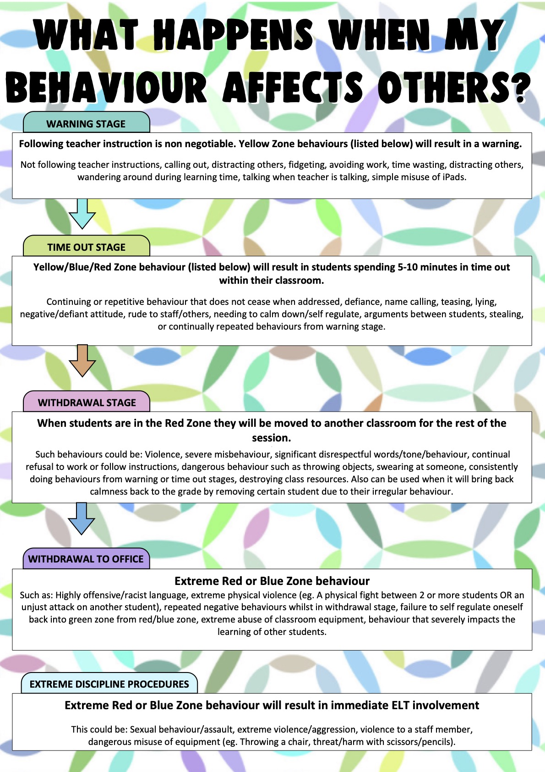
- The school’s values of respect, trust and care
- The school rules
- Rights and responsibilities.
- Student behaviour flowchart (Titled: What happens when my behaviour affects others?)

- School Actions and Consequences
At Fountain Gate Primary School, one of our main goals is to improve the social competence of students. We want to develop empathy, negotiation and problem solving through a restorative justice model, as well as foster relationships and partnerships across the parent community.
We have whole school policies in place which outline the expectations of the school and the consequences if students do not meet those expectations.
Appropriate behaviour
Appropriate behaviour will be recognised by:
- Praise
- References at assembly
- Teacher feedback
- Special celebration events such as Graduation
- The right to represent the school
- Specials excursions
- Leadership opportunities
Inappropriate behaviour will be dealt with by:
- Discussing appropriate behaviour
- Referring studetns to agreed classroom/playground rules and management plans
- Using Restorative practices
- Conference
- Withdrawing students from class
- Time out
- Behaviour Support Plans
- Behaviour contract and the loss of privileges
- Support group meetings
- Referring student to be seen by a counsellor/psychologist
- In extreme cases, suspension or expulsion

Ongoing Behaviour Issues
Where students exhibit ongoing behaviour patterns, as part of staged response a range of strategies will be used. They may include:
- Referring to the school/class values when behaviour is inappropriate. Recognise those students who are demonstrating these values, and give all students the opportunity to practise them.
- Discussing the problem and reaching an agreement for future behaviour
- Completing Behaviour Management Plans and meeting set goals
- Withdrawing students from classrooms, activities, excursions or camps
- Counselling of students through internal/external agencies
- After school detention could be given in case of repeated offence
- Issuing of Suspension and expulsion for serious disciplinary measures
If a suspension or expulsion is considered, schools are required to follow the procedures listed in sections 4.3 and 4.4 of the DEECD guidelines published in Effective Schools are Engaging Schools Student Engagement Policy guidelines.

- Identifying and supporting students with additional needs
Identifying students
Fountain Gate Primary School utilises personalised strategies and approaches in supporting a wide range of individual needs. This includes highly differentiated approaches to literacy and numeracy. These approaches meet the needs of a diverse range of learners. Our school will utilise the following information and tools to identify students in need of extra support by gathering information through:
- Personal information gathered upon enrolment
- Transition forms from pre-schools
- Attendance rates
- Performance in literacy, numeracy, intrapersonal and interpersonal development
- Behaviour observed by classroom teachers and support staff
- Engagement with student families
- Utilising assessment data gathered by the School Support Staff (SSS) team
Assessing need and Providing Support
- Teacher and Integration Coordinator discussion regarding student presenting with additional needs
- Teacher completes FGPS Wellbeing Referral request form
- Integration Coordinator consults with DET Psychologist and Speech Therapist to consider information at fortnightly meeting. Discuss re suitability for referral.
Students who are not referred to SSS team:
- School based support such as Literacy/Maths small group intervention, Individual Learning Plans, speech therapy, home/school program, mental health care plan, modified curriculum, amendments to school arrangements such as attendance, support person, place with funded students, match the child’s needs with a specific teacher, life skills program, chaplain support, school based psychologist, recommend to see paediatrician, after school activities, school nurse, parent education (e.g. Home strategies/school strategies, resources to support extra needs e.g. individualised programs, iPads and other technology) school based speech pathology.
- Refer to Assessments Australia for Intellectual Disability and Severe Language Disorder
Referral to SSS team approved
- Meet with parents and gain agreement on process
- If referral is recommended the child’s name is entered on SOCS (Student online case system)
- SSS service or referred to Assessments Australia
- The child is assessed and the Integration Coordinator determine eligibility for funding from the Program for Students with Disabilities. If the child is eligible, parents are consulted regarding the decision to apply for this funding. If the decision is to apply the Integration Coordinator undertakes this process.
- Out of home care School Support Group meetings with relevant organisations such as OZ Child etc. to monitor child on regular basis.

REVIEW
This policy was last updated on Dec/2020 and will be reviewed in Feb/2024

